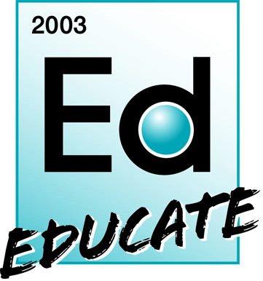

Assignment of Rights and Release for Use of Digital Material
(Photography, Video, Recordings, Multimedia)

Date
Project Name
Project Contacts | Ann Vogel, iBIO Institute EDUCATE Center
I hereby give my permission to iBIO Institute EDUCATE Center, and its parent, subsidiary and affiliate organizations (e.g., iBIO and Argonne National Laboratory) to use my likeness, image, voice, and/or appearance as such may be embodied in any pictures, photos, video recordings, audiotapes, digital images, and the like, taken or made on behalf of iBIO Institute EDUCATE Center. I agree that iBIO Institute EDUCATE Center has complete ownership of and assign all rights to such images, etc., including the entire copyrights, and may use them for any purpose. These uses include, but are not limited to illustrations, bulletins, exhibitions, videotapes, reprints, reproductions, publications, advertisements, and any promotional or educational materials in any medium now known or later developed, including the Internet. I acknowledge that I will not receive any compensation, etc. for the use of such images, etc., and hereby release iBIO Institute EDUCATE Center and its agents and assigns from any and all claims I might have against iBIO Institute EDUCATE Center of any kind whatsoever arising out of the photographing, filming, videotaping, recording or use, transmission, modification or reproduction of the photographs, films, videotapes, or recordings.

I have read and understood this consent and release.
Signature

Print Name

Address

City

State

Zip/Postal Code

Country

Telephone

E-mail

